4/20/2016

Simon Light

Activate Learning

Write Up Document

Computer Science Project

Contents

Analysis 2

Overview 2

Initial 2

Revised with client 2

Use Case Diagrams 2

SMART objectives - specific, measurable, achievable, realistic, time-bound 2

Teacher to System 2

Inputter to System 3

Checker to System 3

Interview plan 3

Questions 3

Sample data 3

Transcript 3

# Analysis

## Overview

### Initial

Who (client) - a teacher (Debbie Light)

What do they want - something to make tests for their students.

Why do they want it - so they save time making tests.

What does it need to do to be judged 'Works' - needs to make tests based on criteria and needs to take input with information about it.

How does the client imagine using it? - Open the program, select criteria (time, level, topic) and the program creates a document with the test in to print. It should also create the mark scheme.

### Revised with client

Who (client) - a teacher (Debbie Light)

What do they want – App which compiles tests according to users criteria.

Why do they want it – Save time finding questions from past papers.

What does it need to do to be judged 'works' - Compile test and mark scheme according to user-set criteria.

How does the client imagine using it – Select a topic and level and limiting factor(time/no of questions) and it shows a series of questions to be able to print/export.

## Use Case Diagrams

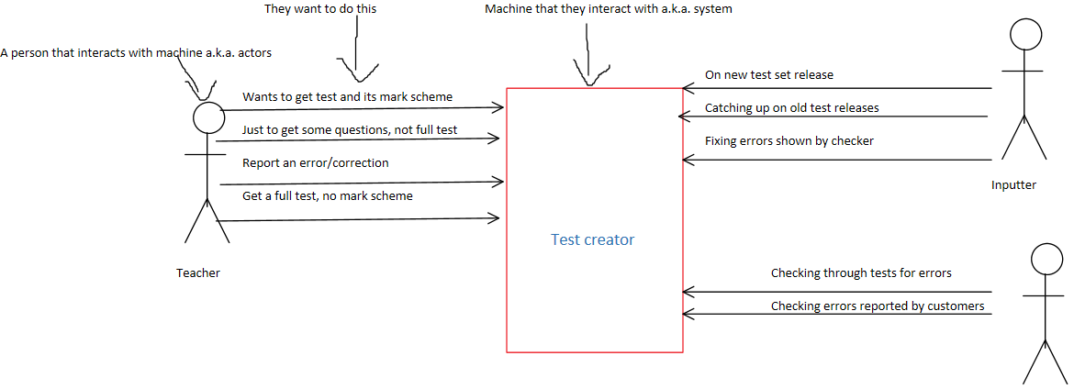

Checker

## SMART objectives - specific, measurable, achievable, realistic, time-bound

Do a smart objective for each of the above

### Teacher to System

Get a test with its associated mark scheme based upon inputted data (i.e. topic, level) within around 10 minutes.

Get a few questions (small test/pop quiz) based upon inputted data (i.e. topic, level) within around 10 minutes.

Get a full scale past paper test, based upon inputted data (i.e. topic, level) within around 10 minutes.

Report a mistake/error, be able to locate where the error is/is found, to be able to be fixed by a member of staff, within a few minutes.

Update the database with either an installer or by dragging it into the appropriate folder.

### Inputter to System

Import a question from a new test, split up question by question, along with the appropriate mark scheme, within 5 minutes.

Import questions from an old test, split up question by question, along with the appropriate mark scheme, within 5 minutes.

Correct an error identified by the checker so that users can update the database to the newer set off data that is correct.

### Checker to System

Check test questions and mark schemes already on the database for errors and flagging them as incorrect with a comment within the required time for each question and less than a minute to flag and report errors.

Check new questions that are about to be put onto the database for errors and flagging them as incorrect with a comment within the required time for each question and less than a minute to flag and report errors.

Verify that the errors spotted by the users

## Interview plan

### Questions

* 1. Would you prefer the program to be online or offline?

* 1. Would you ever use the application on your phone?

* 1. How long do you want it to take to get a tests?

* 1. Would you prefer a login or not?

* 1. What criteria would you like to search with?

* 1. How long does it currently take you to create a test?

* 1. What kind of scenarios would you use the application?

* 1. Would you suggest that your students use the program?

* 1. What kind of special features would you like to have?

* 1. How would you like to report mistakes/bugs? (email, online page, on application)

* 1. What kind of styling would you like the program to have?

* 1. What are the three frustration you have with the current way you find tests?

* 1. Name 3 factors that are most important to you?

* 1. Name 3 factors that are most important to you?

### Sample data

### Transcript